**RetailStoreBackoffice Management Using C#/MVVM/WPF/SQL**

With the help of this application you can manage all retailStore Activities Like :- Supplier Details, Dashboard, Store Details, Inventory, Sales and Purchase Records, User Management etc.  
It's a Small POC Type Project Created By Me And My Team Member Using C#, WPF, MVVM etc.  
Using This small POC, User can handle their Store's Inventory, Store Details, Daily/Weekly Sales and Purchases etc.  
*Hope, you'll love it.*

**Technologies that have been used**

* C#
* MVVM
* Microsoft Sql Server
* WPF

**How to Setup Project in Visual Studio**

1. Requirements:  
   • **Visual Studio (Any version is compatible)**  
   • **Microsoft SQL server**
2. Clone or download project.
3. Open Microsoft sql server and setup DB which we’ve provided in File Name as *RetailDB.sql*
4. Execute RetailDB in sql server. Your ***default username and password will be admin***.
5. Unzip or open downloaded folder and double click on *MyRetailStore.sln*
6. Now it’ll open visual studio. Here you’ve to do one setting. As show in below images, first search for settings.settings in search bar of solution explorer and open settings.settings
7. after that you’ll get following screen(screenshot-2) here you’ve to change value of data source with your server’s name as show in screenshot-3. Finally save it and close settings.settings page.
8. Now just click start on visual studio and enter default credentials.
9. First time you need to create your own credentials. So create your credentials and login using these credentials.  
   *Screenshot-1:* [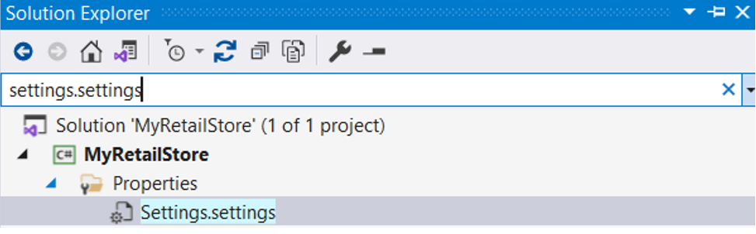](https://user-images.githubusercontent.com/90641894/199454553-ef2974f0-338d-429f-ad36-abf5f2c8fbf3.png)  
   *Screenshot-2:* [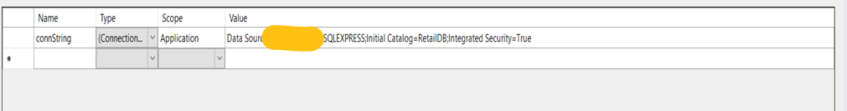](https://user-images.githubusercontent.com/90641894/199454631-b81aff11-9910-4389-abaf-edf98adc960a.png)  
   *Screenshot-3:* [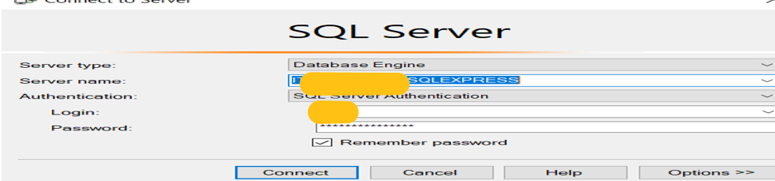](https://user-images.githubusercontent.com/90641894/199454821-e0023c6f-9e25-46cf-b09b-cff12dfba722.png)

Team Members and thanks to them:

* Ajay Sharma: <https://github.com/Dreamer28999>
* Himanshu Trivedi: <https://github.com/himanshuking26>
* Chaitanya Ajabe: <https://github.com/LinUxTo5re>

Licensed by **GNU GPL 3.0**